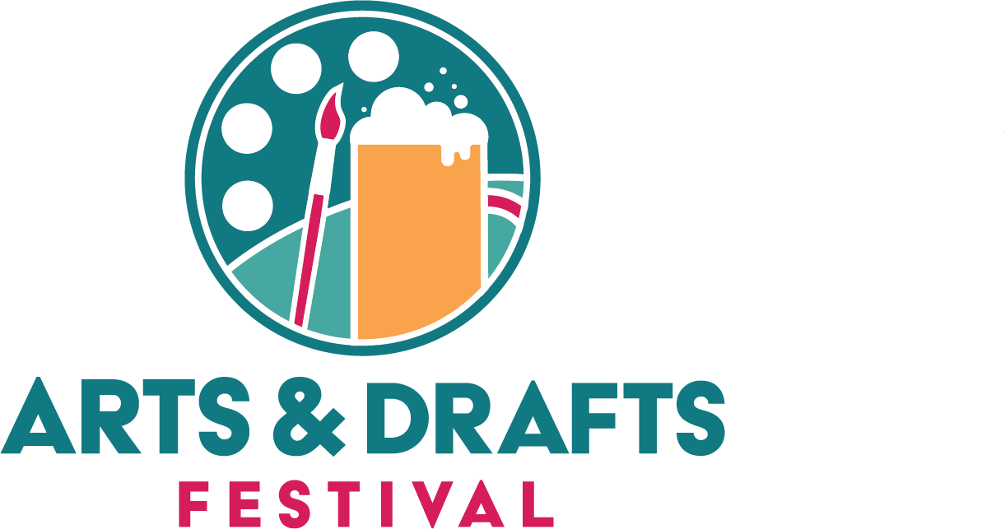

Arts and Dash 5k

SATURDAY | AUGUST 20, 2021 | 8:00am
Ross Park • 82 Randall Rd., Norton Shores
SPONSOR FORM

BUSINESS NAME BUSINESS ADDRESS CONTACT NAME PHONE EMAIL
- $200.00 SUPPORTER OF MONA SHORES
Company logo* on back of t-shirts, can distribute marketing materials at the race, social media mention & opportunity to hang your own company banner/signage at the race – Logos and donations must be received before July 31st, 2022

- $100.00 MONA SHORES FAN
Company logo* on back of t-shirts, can distribute marketing materials at the race
-- Logos and donations must be received before July 31st, 2022

- $50.00 FRIEND OF MONA SHORES
No recognition necessary, I just want to support Mona Shores!

- ANY DOLLAR AMOUNT ::: DONATION $
Mona Shores appreciates any and all support ☺

- DOOR PRIZE DONATION (or) post-race refreshment donation
Please describe:

Please mail check or money order made payable to Arts and Dash with this completed form to
ARTS AND DASH, 2080 Hillside Drive, Norton Shores, MI 49441
QUESTIONS? Email Jamie Sowa at jamie.leroux.01@gmail.com or call 231-206-3781
* COMPANY LOGO = ONE-color only, please email black & white JPG to dfishel@holton.k12.mi.us

